NARROGIN SENIOR HIGH SCHOOL

YEAR 11 ECONOMICS
SEMESTER 2 – 2008

Reading Time before commencing: Ten minutes
Working of paper: 2 ½ hours

MATERIAL REQUIRED / RECOMMENDED FOR THIS PAPER

TO BE PROVIDED BY THE SUPERVISOR

This Question Paper comprising 14 pages and 37 questions
A separate Multiple Choice Answer Sheet
Standard Answer Book

TO BE PROVIDED BY THE CANDIDATE

Standard Items – Pens, pencils, eraser, ruler & calculator

**IMPORTANT NOTE TO CANDIDATE**

No other items may be taken into the examination room.

It is your responsibility to ensure that you do not have any unauthorised notes or other items of a non-personal nature in the examination room. Please check carefully and, if you have any unauthorised material with you, hand it to the supervisor BEFORE reading any further.

INSTRUCTIONS TO CANDIDATES

This paper is in THREE (3) sections:

SECTION A:
Attempt ALL questions (30 questions = 30 marks)
Answer ALL questions in Section A (nos. 1-30) on the separate Multiple Choice Answer Sheet.

SECTION B:
Attempt all THREE (3) Questions (3 questions = 30 marks)
Answers to be written in the spaces provided in this section of the paper.

SECTION C:
Attempt TWO (2) Questions (2 questions = 40 marks)
Answers to be written on the lined paper provided.

SECTION A: MULTIPLE CHOICE

Answer ALL questions on the answer sheet provided by placing a cross (X) over the correct choice. Choose the alternative which most correctly answers the questions or completes the statement.

Suggested time for this section is 40 minutes

1 Economics can be best defined as the study of

(a) resource allocation in a competitive market driven system.
(b) how government, households and firms influence business decision making.
(c) how limited resources affect the efficiency of government households and firms.
(d) how scarce resources are allocated to their most efficient uses in government, households and firms.

2. A production possibilities curve is used to demonstrate that

(a) more of one good can only be achieved by diverting resources away from the production of another good
(b) an economy will operate at any combination of output along the curve
(c) more of one good can only be achieved with an improvement in technology for that good
(d) resources are allocated using price signals indicated at a number of trade-off points along the curve

Questions 3 to 5 refer to the following diagram

Consumer
Goods

r
● w
o

k   l  n

● m

q t v
Capital goods

3 A shift in the production possibilities curve from Oq to Ot may be caused by

(a) an increase in productivity for consumer goods
(b) an overall improvement in productivity for both goods
(c) an increase in productivity for capital goods
(d) more of the existing resources being used to produce capital goods

4. Point k indicates that the economy is operating at

(a) full employment of existing plant equipment
(b) optimal capacity of existing plant and equipment
(c) under employment of existing plant and equipment
(d) an efficient combination involving fewer capital goods and more consumer goods

5 A shift from curve oq to rv can occur when

(a) there is an improvement in technology or an increase in resource availability for both goods
(b) there are structural changes in the capital goods sector allowing efficiency flow-ons.
(c) existing resources and the level of technology are used most efficiently and output in both goods maximised
(d) there is a general economic expansion involving an increase in both average wages and the general price level.

6 The law of demand argues that as prices rise

(a) the quantity demanded will fall
(b) the quantity demanded will rise
(c) the demand curve will shift to the right
(d) quantity demanded will fall due to a decrease in demand

7 The following diagram illustrates the market for child-care services. A shift in demand from D to D1 is best explained by:

Price
D
D₁ S

D

D₁

Quantity

(a) a decrease in the number of young families
(b) an increase in child-care subsidies offered by the government
(c) a reduction in available staff and facilities for child-care
(d) an increase in the price of child-care

8. The direction of the arrow on the graph indicates:

Price S₂
S₁

P

S₂

S₁

0 Q₂ Q₁ Quantity

(a) an increase in supply
(b) a decrease in supply
(c) an extension of supply
(d) a contraction of supply

9 The unemployment rate is calculated as the number of

(a) unemployed persons divided by number of employed persons
(b) persons in the labour force divided by the number of unemployed
(c) unemployed divided by size of the labour force
(d) employed persons divided by number of unemployed persons

10 If prices are expected to rise by 8%, what increase in nominal wages is necessary to ensure a 3% increase in real wages?

(a) 3%
(b) 8%
(c) 5%
(d) 11%

11 Cost-push inflation typically involves an increase in

(a) prices of factors of production
(b) the value of the $A on world currency markets
(c) the level of aggregate demand
(d) profit levels in industry

- Consider the following aggregate demand/aggregate supply schedule

C
A
AD
AS¹
AS⁰
0
Y¹
Y⁰
real GDP (Y)

General
Price
Level
p¹

p⁰

An increase in price from Po to P1 may

(a) have been caused by an increase in aggregate demand
(b) be the result of higher disposable income levels of consumers
(c) have been the result of higher production costs
(d) have been due to an increase in government expenditure

13. The best indicator of economic development is

(a) changes in real GDP
(b) changes in real GDP per capita
(c) an improvement in a wide range of social indicators
(d) a combination of economic and social indicators

14 The effect of higher tariffs on imported commodities effectively subsidizes

(a) domestic consumers
(b) domestic producers
(c) overseas producers
(d) overseas consumers

15 When the value of imported goods and services exceeds the value of exported goods and
services the result is a

- deficit on the balance on goods.
- surplus on the balance on the current account.
- deficit on the balance on goods and services.
- surplus on the balance on goods and services.

16 If, in the Australian economy, investment is $160, saving $150, government expenditure $260, export receipts $130 and taxation $220, then to maintain equilibrium

(a) savings should be $210
(b) imports should be $180
(c) consumption should be $150
(d) taxation should be $250

17. The farmer’s choice of factor mix will depend on:

- the productivity of the factor.
- the price of the factor of production.
- the price received for the final product.
- All of the above

18. Which of the following would lead to a decrease in the supply of lamb on the Australian market?

  - the introduction of higher abattoir fees.
  - an increase in the price of beef.
  - a ban on live sheep exports
  - drought conditions.

- (iii) and (iv)
- (i) and (iv)
- (ii) and (iii)
- (i), (ii), (iii) and (iv)

- An increase in the demand for wool is likely to result from:

  - a successful ‘wool mark’ promotion campaign.
  - a decrease in the price of synthetic fibres.
  - a decrease in real income.
  - a reduction in the supply of wool.

- What effect would a very favourable growing season have on the supply, demand and price of avocadoes?

    - an increase in supply of and demand for avocadoes, with no change in price.
    - an increase in supply of avocadoes, demand remains unchanged, and a fall in price.
    - an increase in the supply of avocadoes, a decrease in demand, and a small fall in price.
    - an increase in demand for avocadoes, supply remains unchanged, and a rise in price.

21. Time lags in farming:

- eliminate shortages and surpluses occurring in production.
- result in uncertainty and instability in agricultural markets.
- enable farmers to predict future profits with greater accuracy.
- delay the impact of diminishing returns.

A decline in the value of agricultural products, as a percentage of total exports since the late 1950s has been mainly due to:

- a decrease in the number of people employed on farms.
- a decline in productivity of the agricultural sector.
- the growth of exports from the mining and manufacturing sectors.
- the effects of environmental factors such as drought and salinity.

23. The large increase in the average level of farm output in the last twenty years is due to:

- a strong rise in the number of women in on- farm employment.
- the increased use of capital equipment on farms.
- increased government assistance for farmers.
- the lowering of on – farm costs.

24. The main function of the financial market is to:

- make loans to consumers and firms
- provide a link between savers and investors.
- charge interest on borrowed funds
- ensure that there are sufficient funds for investment.

25. Which of the following statements regarding financial intermediaries is true?

- all financial intermediaries are equally secure.
- financial intermediaries compete for depositor’s funds.
- the higher the interest rates, the more secure the financial intermediary.
- the actions of one financial intermediary are unlikely to impact on the others.

26. The first step in becoming a public company is:

- issuing a prospectus.
- notifying the Australian Stock Exchange of an intention to list.
- selling new shares on the stock market.
- selling existing shares on the Australian Stock Exchange.

27. The Australian Stock Exchange:

- buys and sells company shares on the stock market.
- administers the buying and selling of securities on the market.
- arranges the buying and selling of existing shares on the market.
- organises the buying and selling of new shares on the market.

28. Which of the following types of assets would have the lowest expected return and the lowest risk?

- government bonds
- blue chip shares
- cash
- property

29. A portfolio made up of which of the following types of securities would be best suited to an investor who requires a steady and regular flow of income?

- blue chip shares, shares in companies with growth potential and some debentures.
- blue chip shares and government bonds.
- highly speculative shares in mining companies.
- shares in companies with growth potential and speculative shares in mining companies.

  - Dividends and earnings per share, price earning ratios, dividend yields, and net tangible assets per share are key ratios studied by:

chartists
  - fundamentalists
  - contrarians
  - technical analysts

SECTION B: DATA INTERPRETATION

Answer ALL THREE questions in the spaces provided in this section of your exam paper.

Suggested time: 40 minutes

31. The data below relates to a modern industrialised economy with similar economic institutions and objectives as Australia.

YEAR | Real GDP  % change | Unemployment Rate | CPI  (1989-90 = 100) | Current Account  Surplus  % of GDP
1998/99 | 3.8 | 8.2 | 115.8 | 3.0
1999/00 | 3.7 | 8.5 | 117.0 | 2.4
2000/01 | 3.6 | 9.4 | 118.2 | 1.7
2001/02 | -0.7 | 9.9 | 120.3 | 1.7
2002/03 | -1.2 | 8.9 | 120.7 | 2.8
2003/04 | 0.7 | 8.6 | 121.8 | 3.0

(a) Define ‘inflation rate’ and demonstrate its calculation for 2002/03. (2)
_________________________________________________________________________________________________________________________________________________________________________________________________________________________________________________________

(b) Identify the stage of the business cycle for this economy, in 2003/04, by reference to two of the indicators shown. (3)

_______________________________________________________________________________________________________________________________________________________________________________________________________________________________________________________________________________________________________________________________________________________________________________________________________________________________
____________________________________________________________________________________________________________________________________________________________________________________________________________________________________________________________________________________________________________________________________________

(c) What measures might the government resort to in response to the economic situation of this country in 2003/4. (5)

________________________________________________________________________________________________________________________________________________________________________________________________________________________________________________________________________________________________________________________________________________________________________________________________________________________________________________________________________________________________________________________________________________________________________________________________________________________________________________________________________________________
____________________________________________________________________________________________________________________________________________________________________________________________________________________________________________________________________________________________________________________________________________________________________________________________________________________________________________________________________________________________________________________________________________________________________________________________________________________________________________________________________________________________________________________________________________________________________________________________________________________________________________________________________________________________________________________________________________________________________________________________________________________________________________________________________________________________________________________________________________________________________________________________________________________________________________________________________________________________________________________________________________________________________________________________________________________________________________________________________________________________________________________________________________________________________________________________________________________________________________________________
____________________________________________________________________________________________________________________________________________________________________________________________________________________________________________________________________________________________________________________________________________________________________________________________________________________________________

  - Read the article below and then answer the questions that follow:
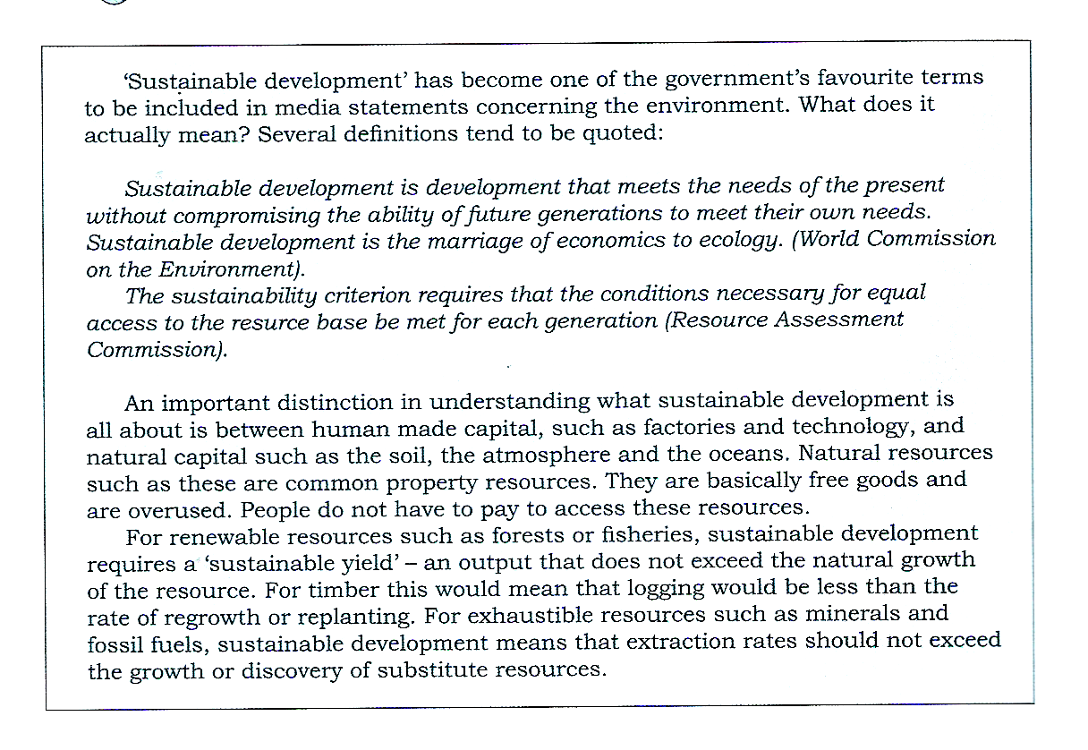

Questions:

  - Explain the meaning of ‘sustainable development’. (1)

  - Distinguish between man made capital and natural capital. (2)

  - What is a common property resource? Why are these goods over used? (2)

  - What is meant by a sustainable yield? (2)

  - How does the price system help encourage sustainable development? (3)

33.
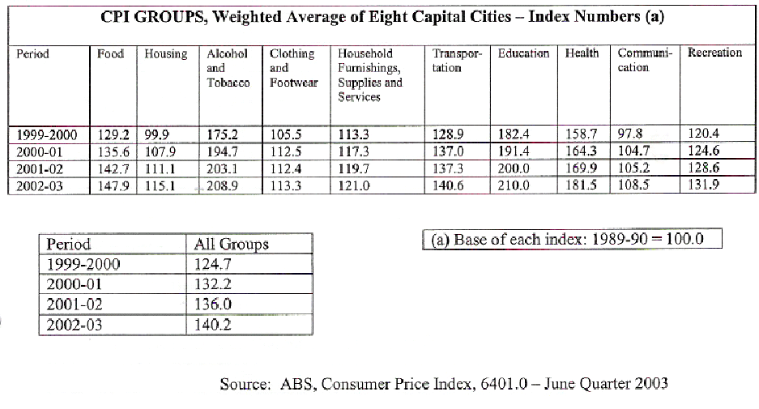
a) Calculate the inflation rate between the years:

i 1999 / 2000 and 2000 / 2001 _____________________________ (1)
ii 2001 / 2002 and 2002 / 2003 _____________________________ (1)

b) In the period 1999 / 2000 to 2002 / 2003 state which group in the CPI
i Recorded the greatest absolute rise in its index _____________________ (1)
ii Recorded the smallest percentage increase in its index _______________ (1)
iii State simply why these different components or groups within the CPI have different weightings attached to them.

_________________________________________________________________________________________________________________________________________________________________________________________________________________________________________________________________________________________________________________________________________________________________________________________________________________________________________________________________________________________________________________________________________________________________________________________________________(1)

c) Discuss some of the main effects inflation can have in an economy. (5)

________________________________________________________________________________________________________________________________________________________________________________________________________________________________________________________________________________________________________________________________________________________________________________________________________________________________________________________________________________________________________________________________________________________________________________________________________________________________________________________________________________________________________________________________________________________________________________________________________________________________________________________________________________________________________________________________________________________________________________________________________________________________________________________________________________________________________________________________________________________________________________________________________________________________________________________________________________________________________________________________________________________________________________________________________________________________________________________________________________________________________________________________________________________________________________________________________________________________________________________________________________________________________________________________________________________________________________________________________________________________________________________________________________________________________________________________________________________________________________________________________________________________________________________________________________________________________________________________________________________________________________________________________________________________________________________________________________________________________________________________________________________________________________________________________________________________________________________________________________________________________________________________________________________________________________________________________________________
________________________________________________________________________________________________________________________________________________________________________________________________________________________________________________________________________________________________________________________________________________________________________________________________________________________________________________________________________________________________________________________________________________________________________________________________

SECTION C: EXTENDED WRITING

Answer a total of two (2) questions (40 marks)
Your answer should consist of at least two pages of normal writing.
Suggested time for this section is 70 minutes. Answer the questions on the lined paper provided.

34. (a) What is Unemployment? How is it calculated? (2)
(b) Distinguish between frictional, structural and cyclical unemployment. Give an example of each. In what sense is there a positive side to unemployment? (10)
(c) Outline the economic and social effects of unemployment. (8)

35. (a) Explain the role and function of each of the following sectors in the circular flow of income. Use diagrams.
a. Households
b. Firms
c. Capital market
d. Government
e. Overseas (12)
(b) Explain the effect upon the circular flow of income of an inequality between planned savings and planned investment. (8)

36. (a) Explain why inflation would cause stock market prices to fall. (3)
(b) What are the factors that affect the share prices? (3)
(c) Explain the usefulness of share price indices to share market traders. (6)
(d) Using appropriate diagrams, show how the price of a share is governed by the market
forces of demand and supply. (8)

37. (a) Explain using appropriate diagram, the operation of an export subsidy. (7)
(b) Outline any five measures which farmers could use to reduce the pressures of cost price squeeze (5)
(c) ‘Pollution occurs because the environment is treated as a free good.’ Explain. (8)

END OF PAPER

